Python Assignment 3 : While Loop, For loop and Function Date of Submission : 09 - 10 - 2026
Name : K.Sreelatha

Screen shot:

Number Guessing Game

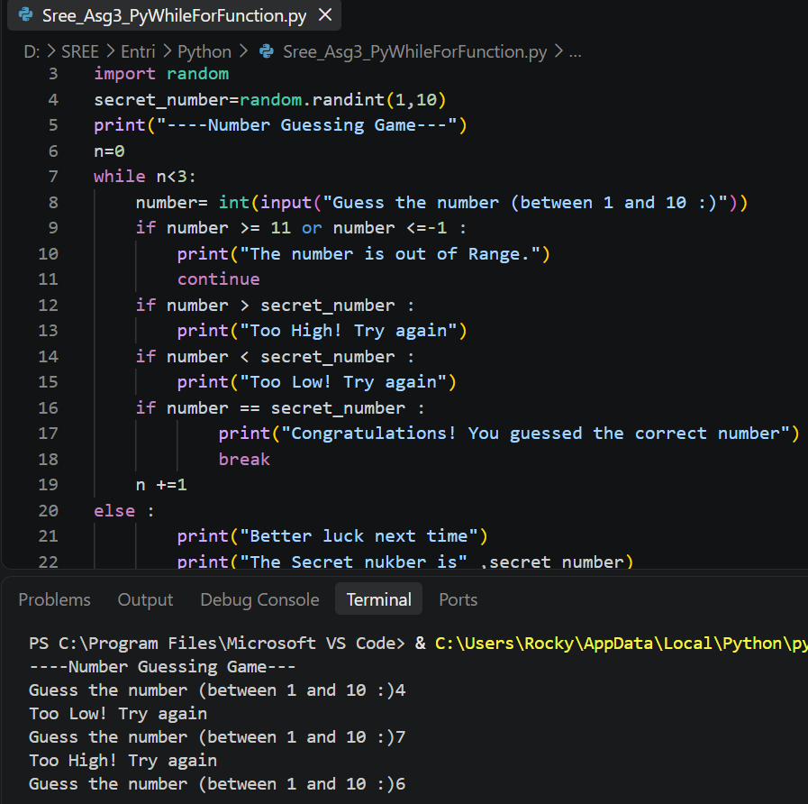
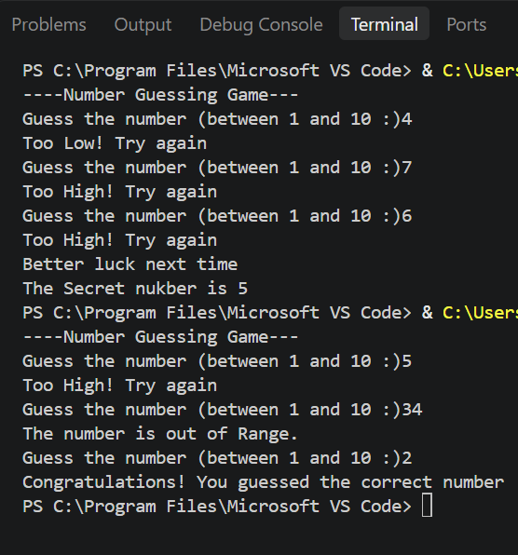

Multiplication Table Generator

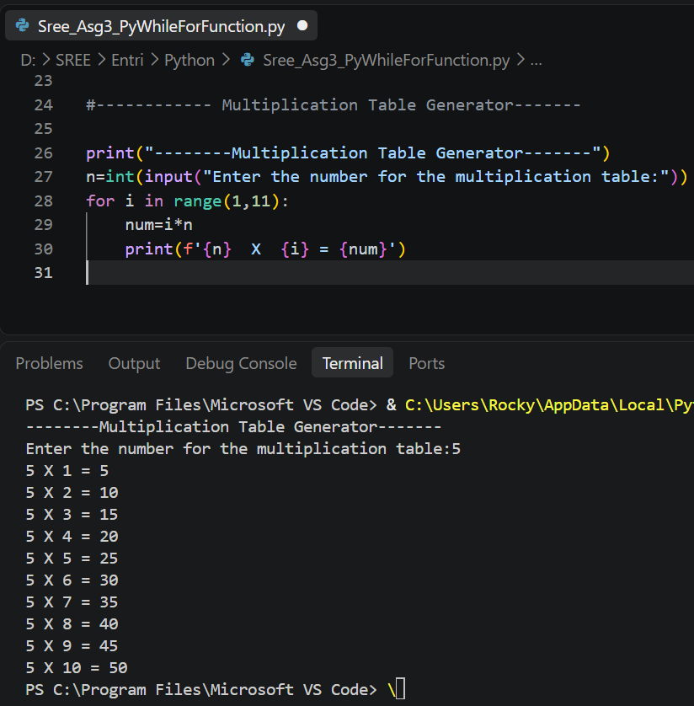

BMI Calculator

